**Server Case**

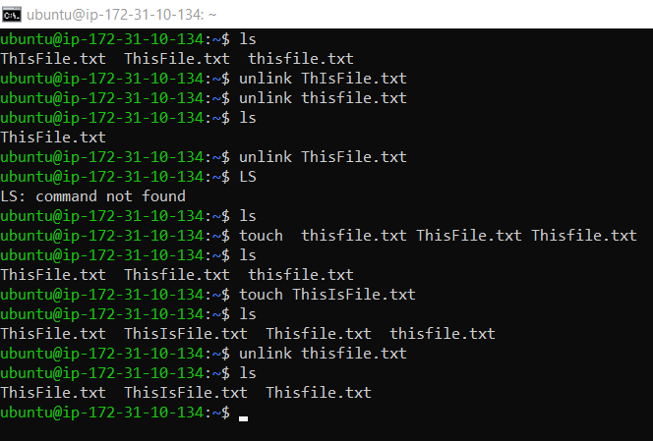

**ubuntu@ip-172-31-10-134:~$** ls

**ubuntu@ip-172-31-10-134:~$** touch thisfile.txt ThisFile.txt Thisfile.txt

(we use touch command to create a file.)

**ubuntu@ip-172-31-10-134:~$** ls

(we use ls command to view our file.)

ThisFile.txt Thisfile.txt thisfile.txt

**ubuntu@ip-172-31-10-134:~$** touch ThisIsFile.txt

**ubuntu@ip-172-31-10-134:~$** ls

ThisFile.txt ThisIsFile.txt Thisfile.txt thisfile.txt

**ubuntu@ip-172-31-10-134:~$** unlink thisfile.txt

(we use unlink command to delete our file.)

**ubuntu@ip-172-31-10-134:~$** ls

ThisFile.txt ThisIsFile.txt Thisfile.txt

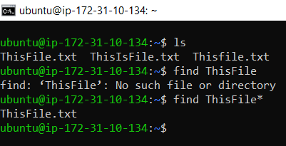

**ubuntu@ip-172-31-10-134:~$** find ThisFile*

ThisFile.txt

(we use find command to find our file.)

**ubuntu@ip-172-31-10-134:~$** man find

( if we want to search case sensitive put this command we got a lot of help.)

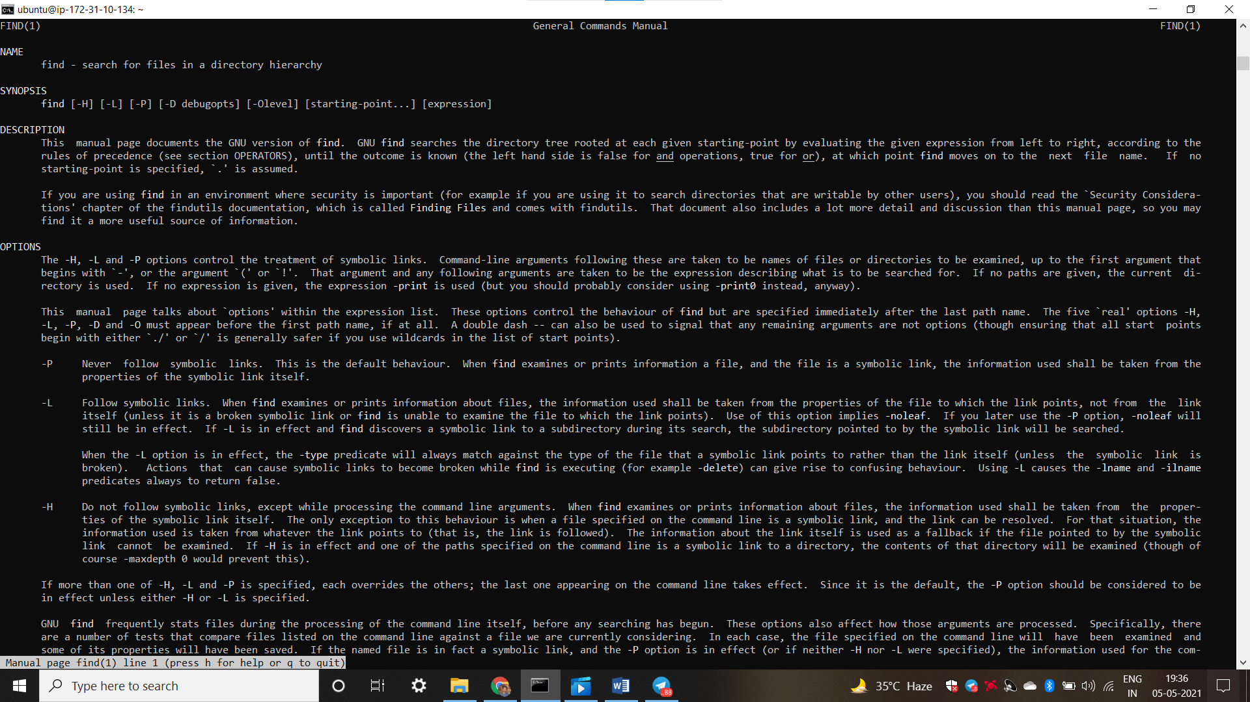

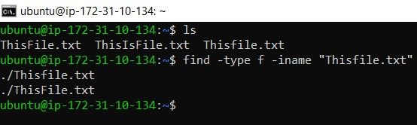

**ubuntu@ip-172-31-10-134:~$** ls

ThisFile.txt ThisIsFile.txt Thisfile.txt

**ubuntu@ip-172-31-10-134:~$** find -type f -iname "Thisfile.txt"

./Thisfile.txt

./ThisFile.txt

(it means linux command are case sensitive.)

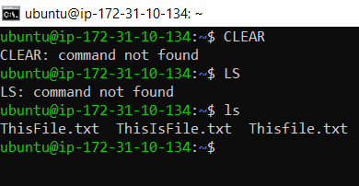

(it means linux command are case sensitive because we give a **CLEAR** command in capital letter that’s why command not found if we give **clear** command in small letter then command execute )

(LS command not found because we give a **LS** command in capital letter that’s why command not found if we give **ls** command in small letter then command execute ).